Thank you for downloading the Master Change Agent Bundle! This group of 13 documents provides all sorts of amazing tools to help you manage an internal change, from concept and strategic planning through measuring success and reporting out to leadership.
These tools are adaptations of actual tools I have used to manage various large organizational change initiatives over the past 15 years and I hope they serve you as much as they have served me.
Please note that I customize every change initiative I design based on the needs and the starting point of the organization. These tools are meant to provide a starting point, but they are not meant to constrain you. Feel free to adjust, adapt, and discard any of the tools that do not serve you.
If you come up with other tools or have an idea to tweak these tools to make them better, send me an email at mary@evolveYourPerformance.com and let me know. I’m all about continuous improvement and growth and would love to update these tools as needed.
Finally, if you would like to see how EVOLVE could work with you to design and/or implement your custom change program, reach out to me directly and we will set up a time to discuss how EVOLVE can help.

Master Change Agent Bundle Organization

The contents of this bundle are organized based on the framework to the left, the five elements of becoming a master change agent.
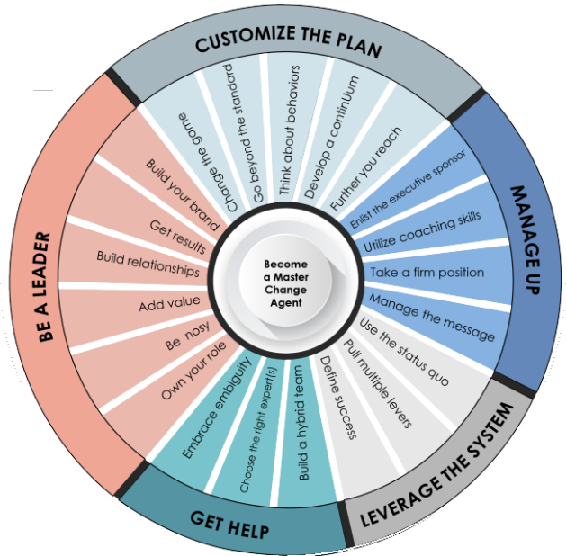
Be a leader – To help with the section, there is a Change Leader Self-Assessment (01) document that you can use to determine your strengths and opportunities for development. One of the attendees on a recent workshop on this topic shared that she even planned to put employees’ names in the expert cell for each area in the self-assessment so she could ask them to be a mentor, either formally or informally. I thought that was a great (and unexpected) way to use the document.
Customize the Plan – To support your efforts of customizing the change plan, I have included a Change Customization Worksheet (02). It is a group of behavior-based exercises that can walk you and your change team into developing both a change continuum and a list of initiatives that will directly impact the defined objectives of the change.
Manage Up – Managing up is a large part of any successful change agent’s job. So, there are a few documents included to support you in these efforts. There is a document to help you identify a great executive sponsor or work with your current executive sponsor to get the support you need (03). There is also a document that talks about creating a change charter and what should be included in such a document (04). The next three documents are in support of having a Leadership Spitball Conversation. The first document (05) talks about the process of having that conversation and how the other two tools are used. I have also included a template for taking notes (06) and putting it all together in a sunray chart (07). The final document for this section is a Message Map Template (08) to help make sure all messaging is in line with the change plans.
Leverage the System – The next section is about leveraging things like existing and new metrics to drive the right behavior. To that end, I have included a Change Scorecard Template (09) which walks you through creating meaningful metrics for the change and is formatted to provide a leadership friendly dashboard based on those metrics. The other document for this section discussed conducting a metric audit (10) to make sure all existing metrics are not sabotaging the change efforts.
Get Help – The last three documents are intended to help you build your coalition of people to help with the change. You need people who have a high tolerance for ambiguity, so there is a tool to help you measure that (11). Then, you will likely need to build an internal team, so there is a document to help you with that (12). Finally, you may need to hire external support as either staff augmentation or to provide specific expertise. There is a document to help give you some ideas for this as well (13).
I do hope some of these documents and tools will help you as you and your organization navigate through your change. If there is anything EVOLVE can do to provide that extra bit of experience and guidance in your efforts, please reach out to EVOLVE’s founder directly at mary@evolveYourPerformance.com so we can talk about the best way we can help. Good luck on your change!

